COMHAIRLE CONTAE AN LONGFOIRT

LONGFORD COUNTY COUNCIL

Corporate Affairs,
Aras an Chontae,
LONGFOIRT.

7th August 2015.

To: The Cathaoirleach and Members of Longford County Council

A Chomhairleoir,

On the direction of Cathaoirleach, Councillor Gerry Warnock, you are requested to attend a Special Meeting of Longford County Council to be held in the Council Chamber, Aras an Chontae, Great Water Street, Longford on Monday, 17th August 2015 at 4.00 p.m.

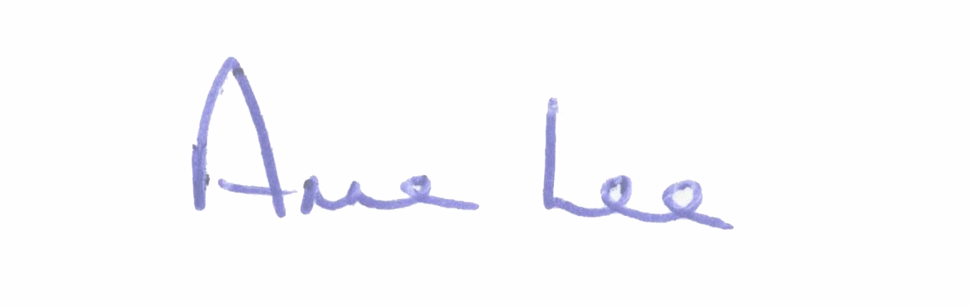
Mise le meas,

Anne Lee
Meetings Administrator.

C L A R

Prayer before meeting.

- Direct provision facilities in Longford town - accommodation for asylum seekers.

